**Lesson 15**

If you stood in a stream of water. You would not move. However, if you stood in a river then you would be washed away. However, the speed of the movement of the water is the same. It is just that the amount of current is more.

If you step off from a table, to the ground you experience air resistance. If you stepped off into custard, wet concrete or quick sand you would touch the ground however it would take longer. This is what resistance is in a circuit.

Potential Difference = Volts (V)

Current = Amps (I)

Resistance = Ohms (R or Z)

Resistance is opposition to current flow.

This is why we have insulation around cables. Because, the resistance is so high that electricity cannot flow through it.

**Current** is the flow of electricity.

**Voltage** -> Measurement of electricity. Voltage is not electricity.

**Conductors** -> the atoms in a conductor have loosely bound electron atoms. When you provide the electrons with additional power the electrons pass on electrons to the next atoms. It is the passing of electrons.

**Insulator** -> the atoms inside an insulator have tightly bound electrons. This means that the electrons cannot move between atoms very easily.

**Voltage drop** -> occurs because even in a normal flow electrons and electricity will be lost.

**Three effects of electricity:**

1. Magnetic
2. Thermal
3. and Chemical (lithium ion)

One side has a lot of electrons. One side is hungry for electrons.

Magnetic - an electromagnetic which spins.

**Example 1**

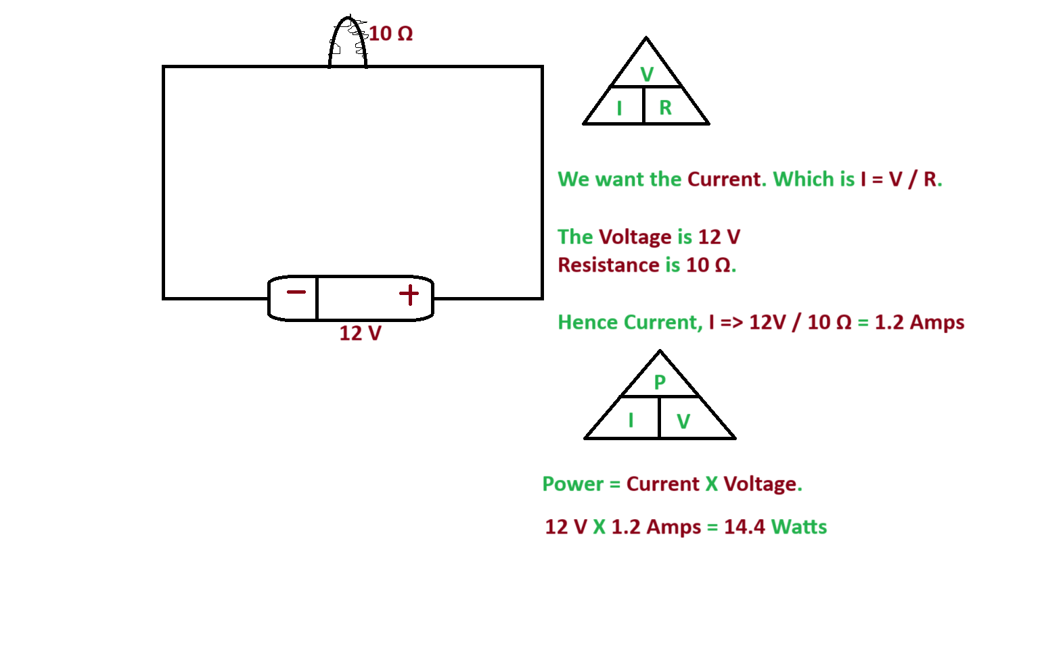

**Example 2**

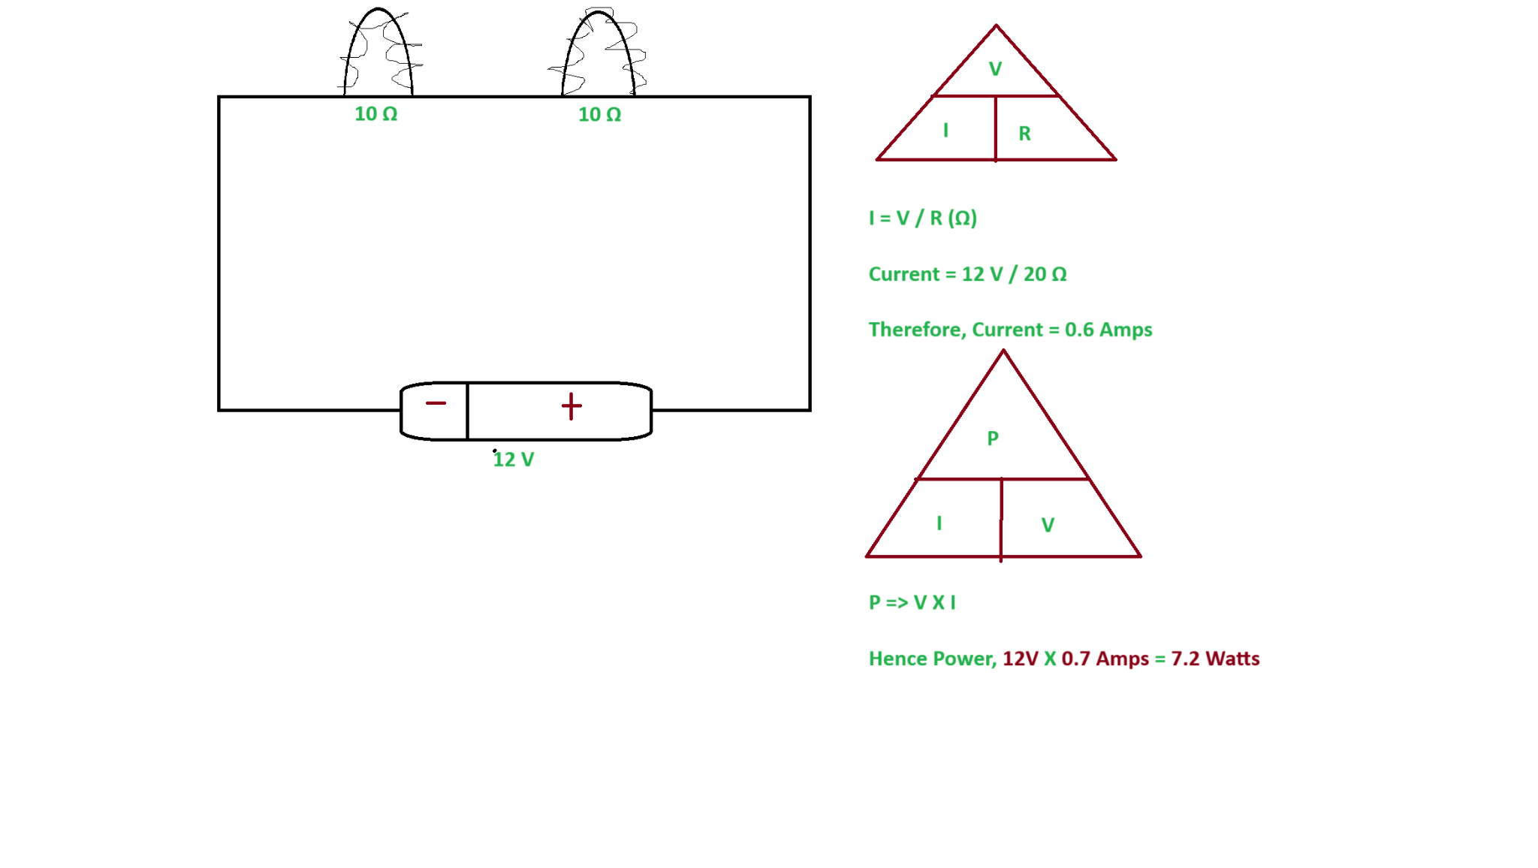

**Example 3**

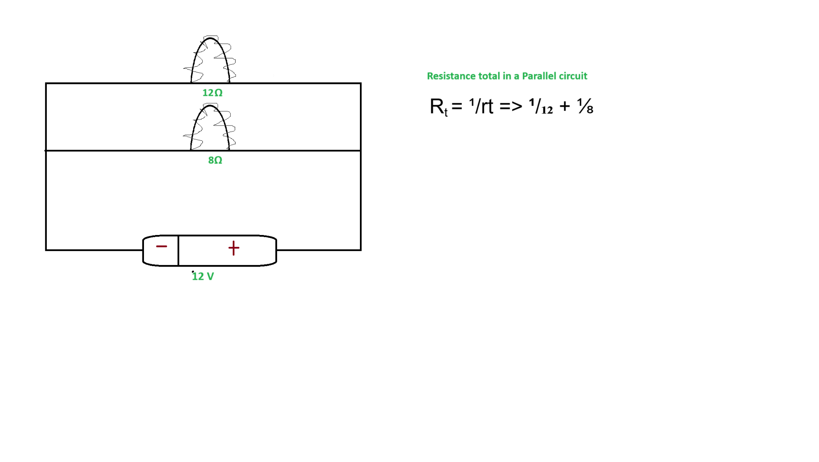

**Rt** = **¹/rt** => **¹/₁₂** + **⅛**

(**0.208** = **0.083** + **0.125** )

**¹/0.208 = 4.8 Ω**

**V / R = I**

**12 V / 4.8 = 2.5 A**

**P = V X I**

**30 W = 12 x 2.5**

**Example 4**

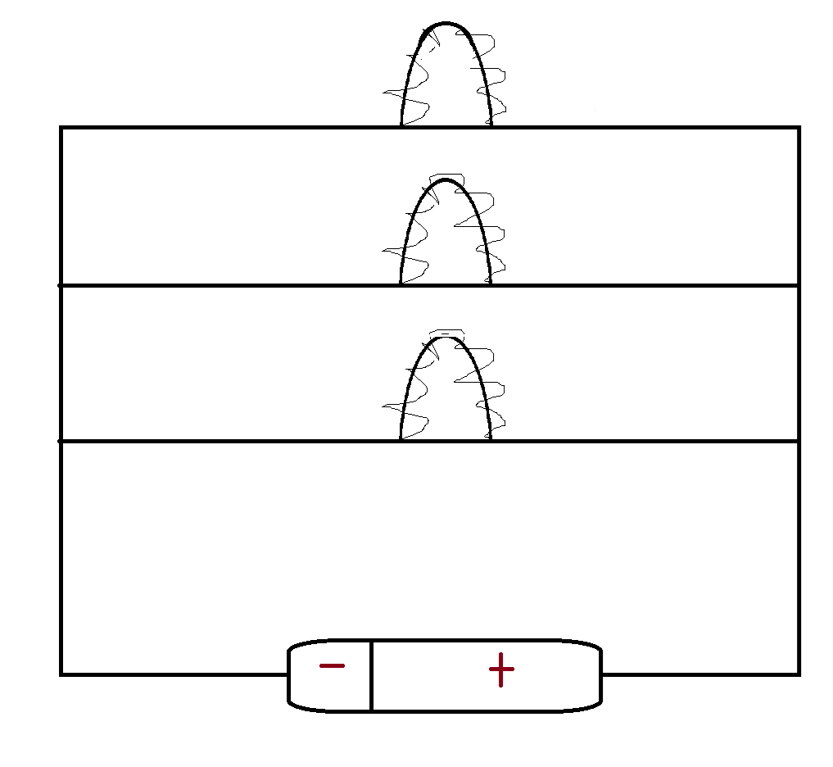

A parallel circuit reduces resistance. This means more power. Resistance is reduced because there is more than one pathway for the electricity to flow. Less resistance means more power is used.

When we test we want parallel circuits. Circuits are connected in either series or parallel.

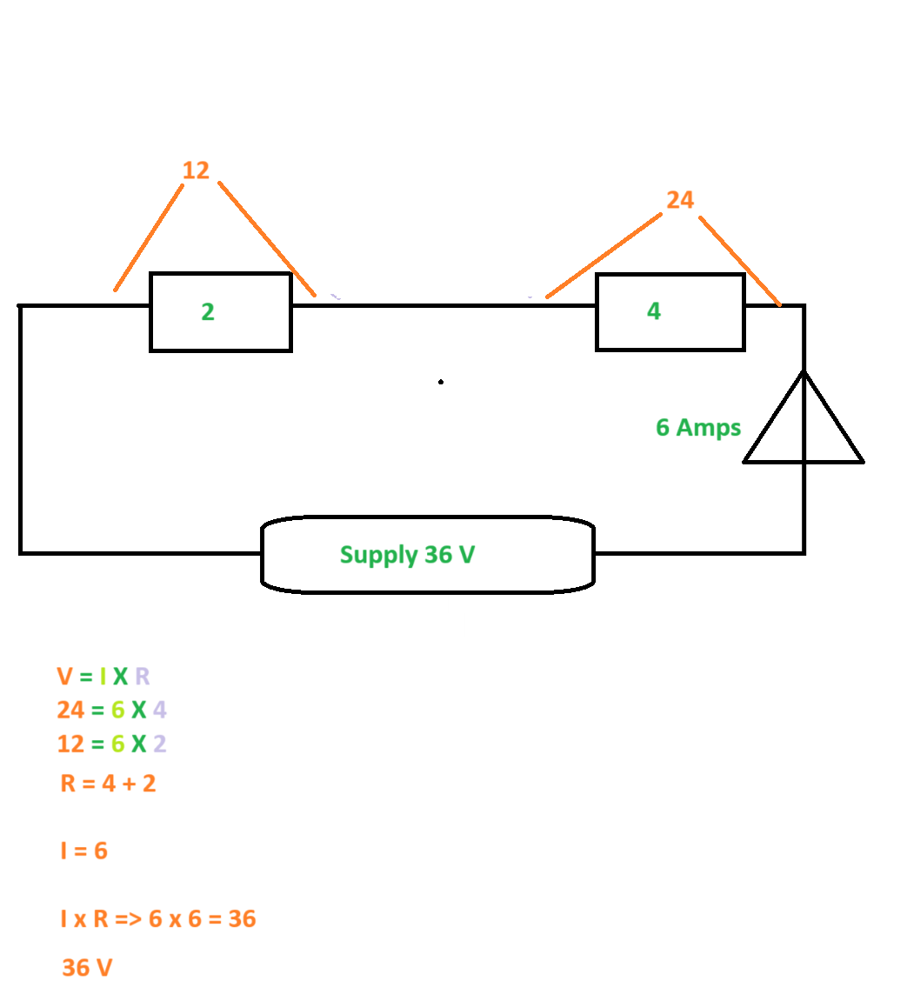

**Example five**

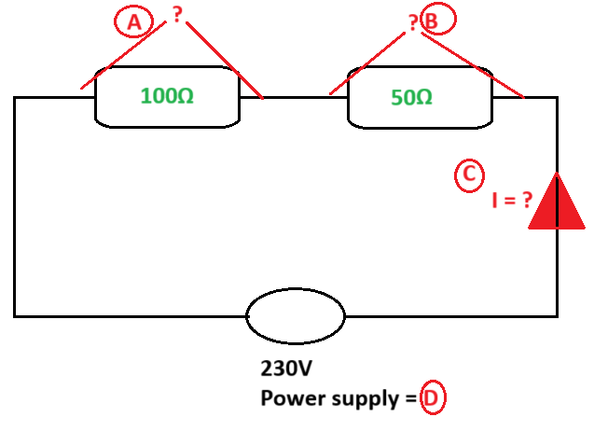

**Example 6**

